NuAnchor — demo walkthrough
A 3½-minute demo, scene by scene. What to click, what to say, and the number to land in each shot. Screens captured from the live app on 31 July 2026.
Product: nuanchor.nustack.tech · this script runs on /demo/live · the buy desk is /demo/workspace
The numbers here are real. Every figure below is what the sample file actually produces. Read them out with confidence. If you upload a client's file instead, the numbers will be different — that is the whole point — so learn the shape of the story, not the digits.

Before you start
Tabs | Open /demo/live — that is the whole demo. Keep /demo/workspace in a second tab for scene 7; you switch to it once.
Window | 1440 × 900, nothing else on screen. Hide the bookmarks bar, turn off notifications, close Slack. Zoom at 100% — the numbers are the point and they need to be readable.
State | Click Reset the demo before you begin. If you have been rehearsing, reset again — a half-run demo is the one thing that looks broken.
Presenter notes | The page ships with cues visible. Great for rehearsal, distracting on a call or on camera — hit Hide presenter notes, top right.

Scene 1 · The hook
0:00 · 12 seconds · `/demo/live`
Why this decision matters.
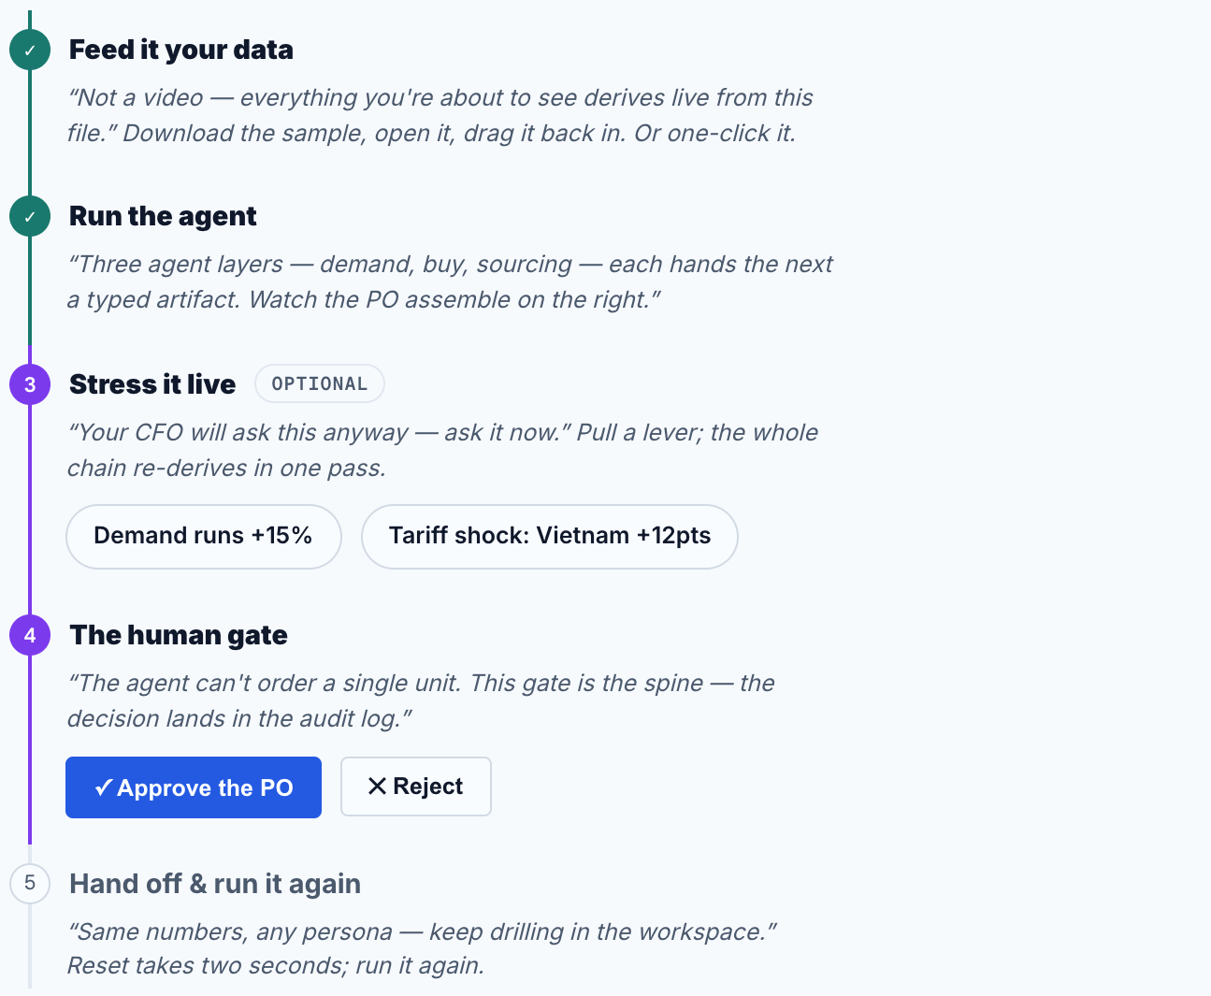
The live demo opens as a five-step checklist, step one asking for a sell-through file.
Say:
"Every season, a brand commits most of its cash to what it's going to buy — months before anything sells. Get it wrong and you're either sold out of the good stuff or discounting the rest. NuAnchor makes that call with you. Let's do a real one, start to finish."
Do: nothing yet. Let the empty screen sit for a beat while you say the line — it makes the fill-in later feel like something happened.
Scene 2 · Feed it your data
0:12 · 30 seconds · `/demo/live`, step 1
Prove it isn't a video.
Do:
- Click Download the sample CSV first. Open it — let them see it is an ordinary spreadsheet of styles and sell-through.
- Drag that file back onto the drop zone. (Short on time? Use the sample file does it in one click.)
- Pause on the confirmation line: 8 styles matched.
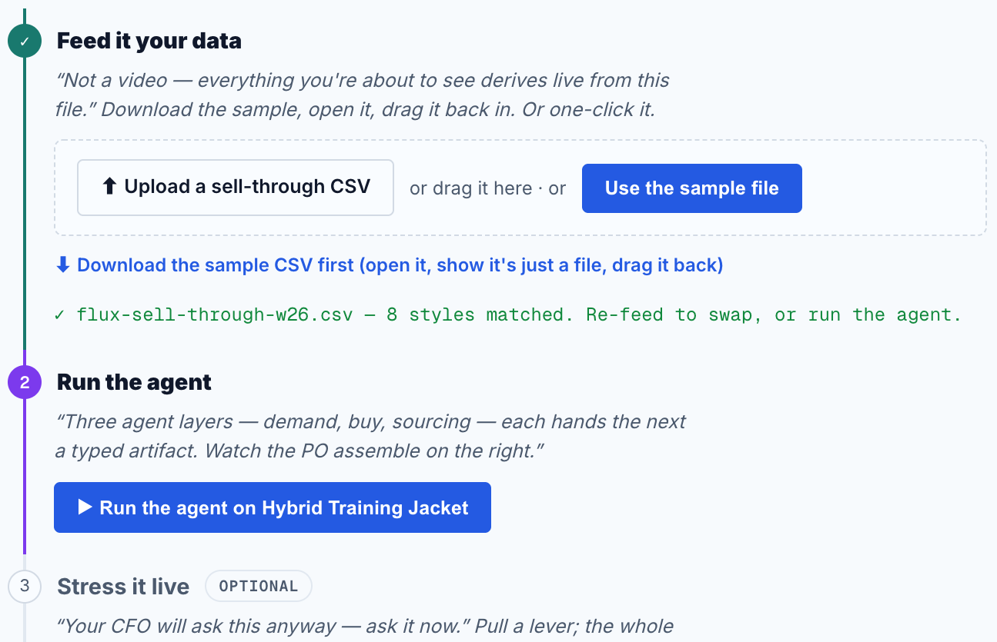
File in, styles matched, one button left to press. The step ticks green — the demo keeps its own score.
Say:
"This is a sell-through file — the kind of export any planner can pull in a minute. I'll drag it in. Nothing here is pre-recorded: everything you're about to see is calculated from this file, and on a real call this would be yours."
Why this scene earns its 30 seconds: it kills the biggest silent objection in an AI demo — "is this a canned video?" Showing the file, then dragging it in, answers it before anyone asks.
Scene 3 · Run it, and let the agent show its work
0:42 · 50 seconds · `/demo/live`, step 2
Do:
- Click Run the agent on Hybrid Training Jacket.
- Don't talk over the first two seconds. Let the activity feed on the left start writing itself.
- Follow the three passes as they land — demand, then buy, then sourcing. In a hurry, Skip to the staged PO jumps to the end.
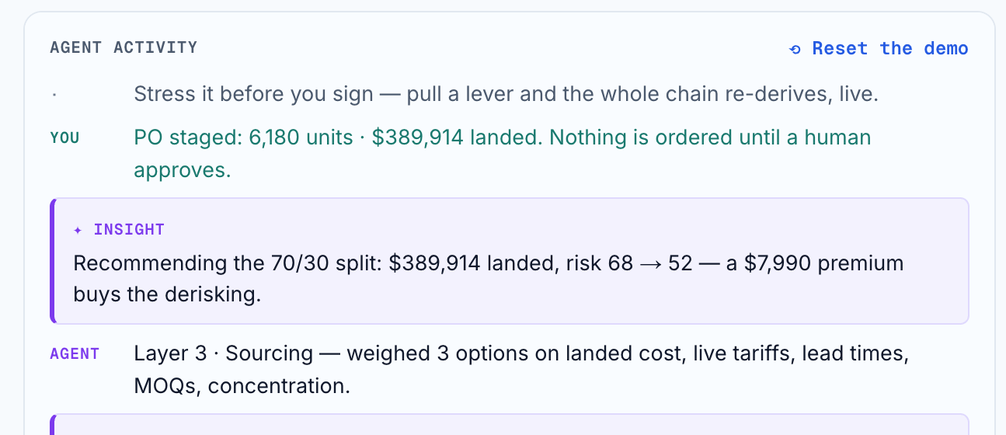
The activity feed narrates each pass as it computes and quotes the number it just produced. Read from it — you don't need to memorise anything.
Say:
"It reads the file — eight styles — and picks out the biggest mover: this jacket is running 10% ahead of plan. Then three passes. What will actually sell: 7,480 units, and it gives me a range, not a single fake-precise number. How many to buy: I already have 1,300 covered, so I need 6,180. Who to buy from: it prices every supplier option, lands at $390,000, and cuts the sourcing risk from 68 to 52."
"Notice what it's doing — it explains each step as it takes it. Nothing here is a black box you have to trust."
The numbers to land:
7,480 units | demand read
6,500–8,500 | range at 90%
6,180 units | to buy, net of 1,300 covered
$389,914 | landed cost
68 → 52 | sourcing risk

If someone interrupts here, the question is almost always "where did 7,480 come from?" — good, that's the demo working. Answer: "three signals — search interest, social, and last season's sell-through, anchored on the file you just watched me upload." Then keep moving. Scene 5 is where you let them push on it.
Scene 4 · The purchase order
1:32 · 25 seconds · `/demo/live`, right panel
The thing they actually recognise.
Do: move the cursor slowly down the PO on the right. Stop on the supplier split. This is the moment the room stops thinking "AI feature" and starts thinking "this is my job".
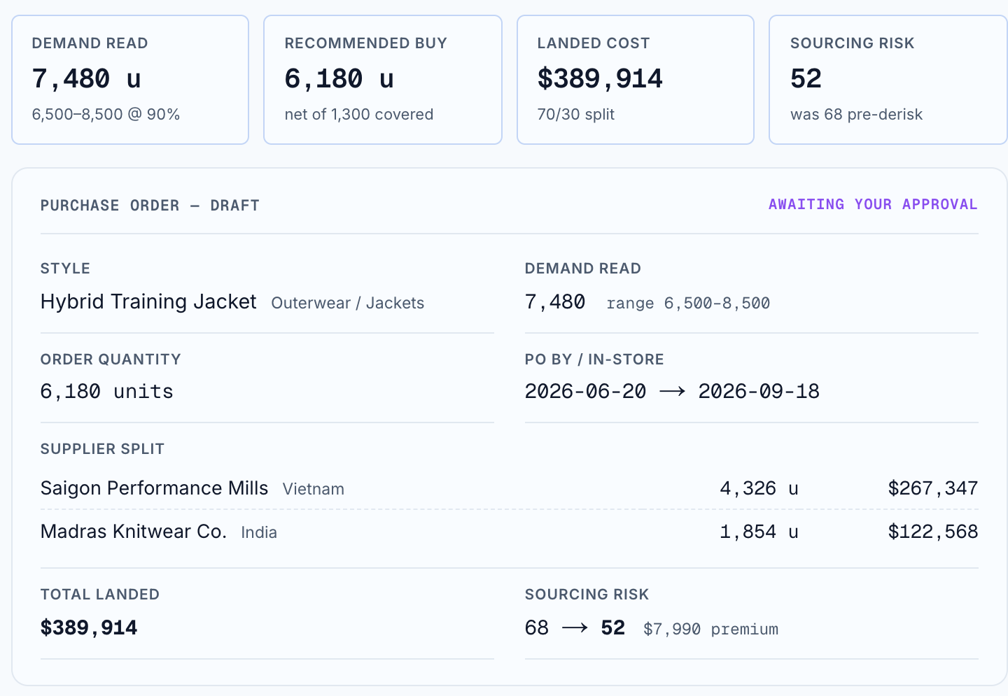
A complete, ready-to-send purchase order — quantity, dates, two named suppliers, landed cost, and "awaiting your approval" in the corner.
Say:
"And out comes a purchase order you could send today. 6,180 units, ordered by 20 June to be in store by 18 September. And look at this — it didn't put the whole order in one country. 70% Vietnam, 30% India. That split costs about $8,000 more, and it buys down the risk of one tariff change or one late factory wrecking the season. It'll tell you that trade-off out loud."
"Top right: awaiting your approval. It has not ordered anything."
Scene 5 · Stress it live
1:57 · 30 seconds · `/demo/live`, step 3
Ask the awkward question yourself.
Do:
- Click Demand runs +15%. The whole plan re-derives in one pass — watch all four tiles move together.
- Click it again to switch it off, then click Tariff shock: Vietnam +12pts.
- Leave the levers off before you move on, so the PO matches what you described in scene 4.
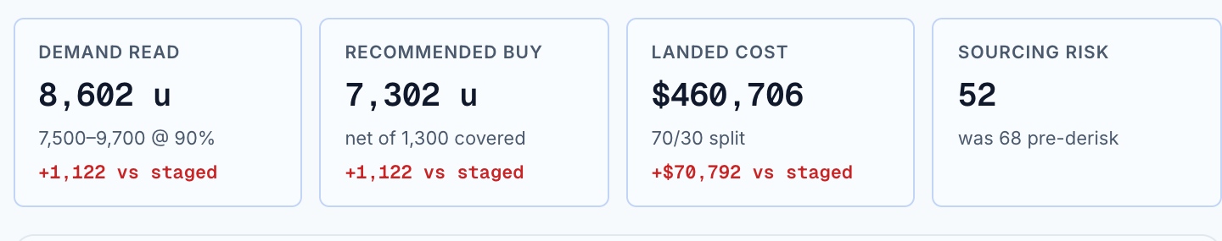
Demand runs +15% — the read goes 7,480 to 8,602, the buy 6,180 to 7,302, the cost $389,914 to $460,706. Every tile prints its own delta against the staged plan, so nobody has to do the subtraction.
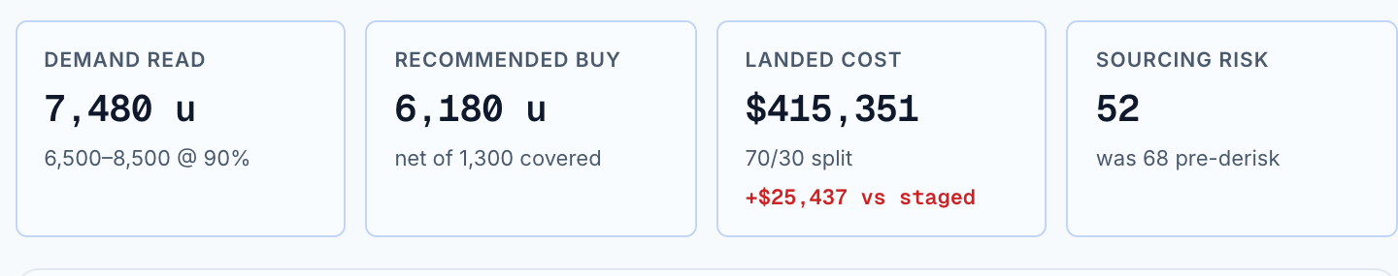
Tariff shock, Vietnam +12 points — same units, but the bill goes $389,914 to $415,351: plus $25,437, printed on the tile. The split and the risk score hold — it had already hedged.
Say:
"Your finance team is going to ask 'what if it sells faster than that?' — so let's ask now. One click. Demand up 15%, and the entire plan re-derives — the buy, the cost, the supplier quantities, all at once. No second spreadsheet, no analyst rebuilding it overnight."
"And the one everybody's living through: a duty jump in Vietnam. Same units, but the bill goes up $25,000 — and because it had already spread the order, the risk score doesn't move. That's what the hedge was for."
This is the scene that wins skeptics. Most planning tools can show you a number. Very few let a stranger change an assumption mid-meeting and have every downstream number move in one pass. If the room only remembers one scene, make it this one.
Scene 6 · The human gate
2:27 · 20 seconds · `/demo/live`, step 4
Nothing ships without a person.
Do: click Approve the PO. Then point at the two things that appear: Export the PO handoff and Audit entry (CSV).
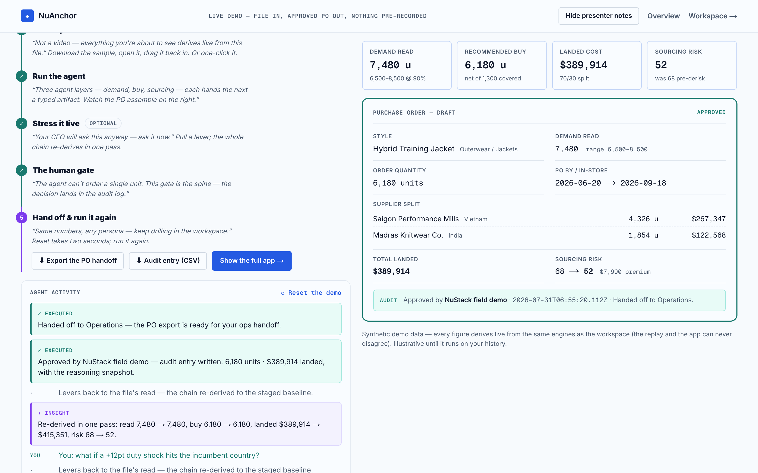
Approved. The audit line records the units, the cost, and the reasoning behind them — then hands off to ops.
Say:
"The agent cannot order a single unit. This gate is the only way out — someone approves, adjusts, or says no. And when I approve, it writes an audit entry with the reasoning attached, so in three months when someone asks why we bought 6,180, the answer is on file. Then the order goes to ops the way your orders go today."
Scene 7 · The buy desk
2:47 · 25 seconds · `/demo/workspace`
What Monday morning looks like.
Do: switch to your second tab, then click Open Decisions. Skip this scene entirely if you are under time — the demo still lands without it.
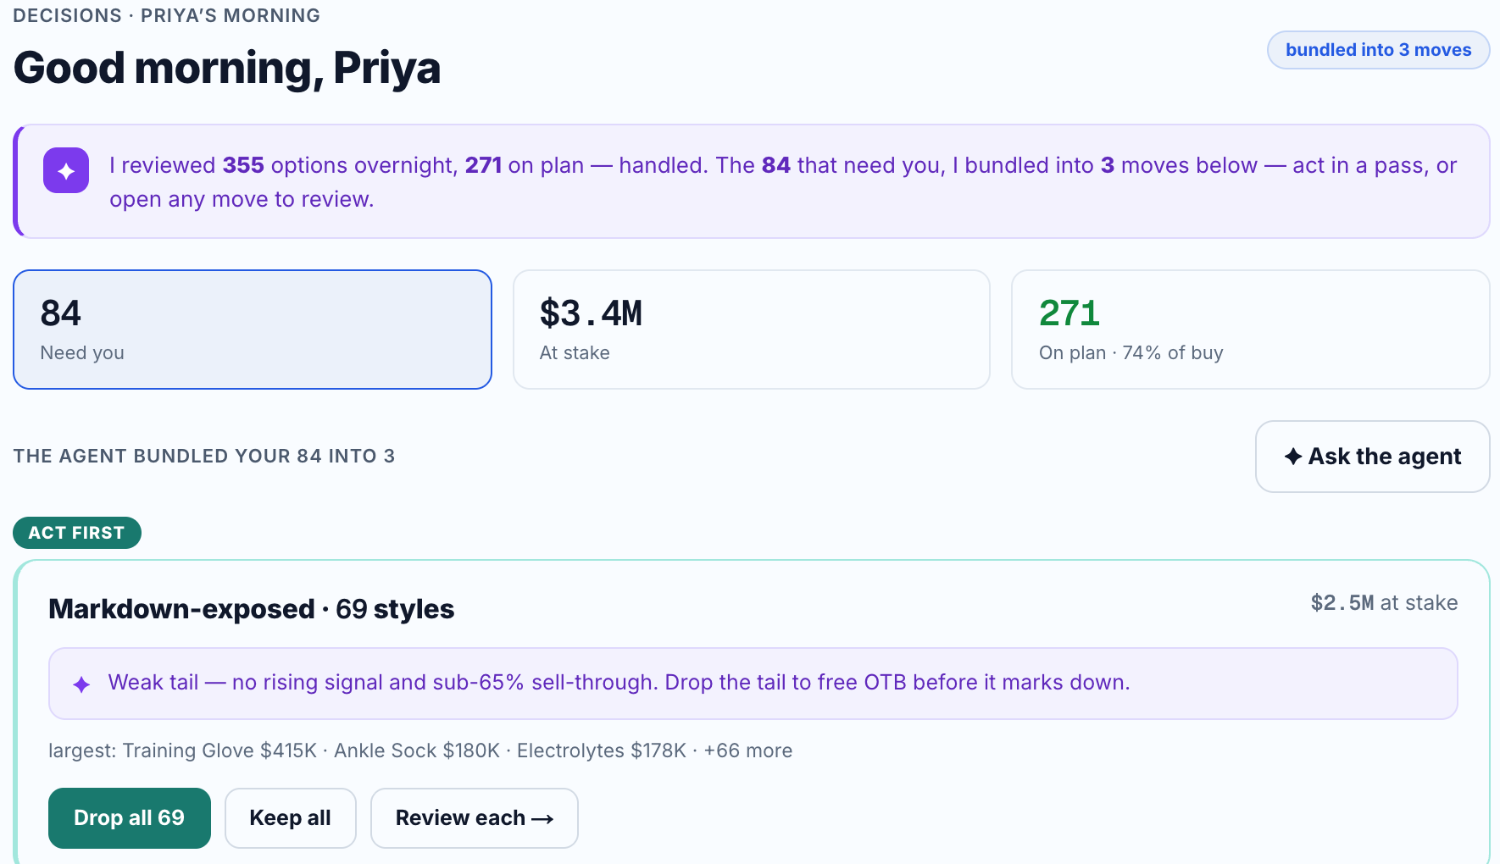
355 options reviewed overnight, 271 on plan and handled, and the 84 that need judgement bundled into three moves a planner can act on in one pass.
Say:
"One order is the demo. This is the job. Overnight it went through 355 decisions on the season — 271 were on plan, done, no one needed. 84 needed a human, and rather than dump 84 rows on a planner it grouped them into three moves: drop the weak tail, trim this jacket, fix the ones that can't hit supplier minimums. She clears her morning in three decisions instead of eighty-four."
A nice detail if you have a spare beat: top right, Agent handled — 2. It approved one style and rejected another on its own, both logged with the reasoning. Use it to show autonomy is a dial the client sets, not a switch we flip.
Scene 8 · The close
3:12 · 15 seconds · any screen
Say:
"So: NuAnchor reads what's selling, sizes the buy, shops it across suppliers with the tariff maths done, and hands you a purchase order with its reasoning attached. Nothing is ordered until a person says yes, and every decision is on the record. It's live at nuanchor.nustack.tech — bring a sell-through file and we'll run yours."
If you are recording: stop talking, wait two seconds, then stop the recording. Trailing silence is easy to trim; a clipped last word isn't.

Explaining it to someone with no retail background
New to the team? Start here. No jargon — and it is the version to use on a first call.
Imagine you run a clothing brand.
In March you have to decide how many winter jackets to order — before a single customer has tried one on. Order too many and you're discounting them in January. Order too few and you're sold out in November, watching people leave.
Most brands make that call in a spreadsheet, using a price a factory emailed them.
Then import taxes started jumping. So now even the price isn't fixed — a jacket you budgeted at $40 can cost you $45 by the time it clears customs. That difference is your profit.
NuAnchor does that whole calculation. How many to order, which factory to use, and what it will really cost after taxes — and it shows its working, so a person still makes the final call.
The words a client will use
When the client says | They mean
Sell-through | How fast something sold. "59% sell-through" means they have sold 59 of every 100 they bought.
Landed cost | The real price per unit once shipping and import taxes are added. The number that decides profit.
The buy | The whole order for a season. "The season buy" is the single biggest cheque they write.
Markdown | A discount they did not want to give, because they bought too many.
Stockout | Sold out of something people still wanted. Lost sales, invisible on any report.
MOQ | Minimum order quantity — the factory will not make fewer than X, so small orders do not work.
OTB / open-to-buy | How much money they have left to spend on stock this season.
Purchase order (PO) | The actual order document sent to the factory. NuAnchor's output.

The one-sentence version: a brand has to bet most of a season's money on what will sell, months early, and import taxes keep moving the price. NuAnchor makes that call with them and shows its reasoning. If you can say that, you can open a conversation.

The 60-second cut
For an email, a LinkedIn post, or the top of a cold call. Same recording, three scenes — skip the setup story and the buy desk.
Keep | Scene | The one line
0:00–0:15 | 2 · your file in | "A sell-through file goes in. Nothing here is pre-recorded."
0:15–0:40 | 3 + 4 · run and PO | "It reads demand, nets what you hold, shops it across suppliers — and out comes a purchase order."
0:40–1:00 | 6 · the gate | "Nothing is ordered until a person says yes, and the reasoning is on file. nuanchor.nustack.tech."

Cut scene 5 last. If you can stretch to 90 seconds, put the tariff lever back in instead of anything else. It is the most differentiated fifteen seconds we have.

Words
Say the left column. The right column loses rooms.
Say this | Not this | Why
"It decides how much to buy" | "agentic decision chain" | Buyers don't buy architecture. They buy the decision.
"It shows its work" | "glass-box explainability" | Everyone understands showing your work. Nobody asked for a glass box.
"A person says yes" | "human-in-the-loop approval gate" | The plain version is the reassuring one.
"What it'll cost landed, duties included" | "landed-cost and tariff optimisation layer" | Say the money, not the module.
"It gives you a range, not one fake-precise number" | "90% confidence interval" | Same fact, no statistics lesson.
"Overnight it cleared the routine ones" | "autonomous exception triage" | Describe the morning, not the mechanism.

Two words to keep. Landed cost and sell-through are the client's own words, not ours — a merch planner uses both daily. Using them correctly is how you sound like you have done this before.

The four questions you will get
Is this running on real data?
No — and say so plainly. The sample season is synthetic and the app says so at the bottom of the screen. What is real is the machinery: the same engines produce every number you see, and it runs on a file you hand it. Then make it an ask — "send us a sell-through export and the next demo is yours."
Can I trust AI to commit my inventory?
Point at the gate. The agent cannot place an order. Approval is the only exit, the limits are set by the client (supplier policy, budget envelope, minimum order quantities), and every decision is logged with its reasoning. If they are still cold, offer to run it in parallel with their existing process for one season and compare.
How accurate is the forecast?
Don't sell accuracy you can only prove a season later. Sell what is checkable today: the reasoning holds together, and the landed-cost and duty maths can be verified against their own invoices line by line. Then mention the loop — after the season the read is scored against what actually sold, so next season starts sharper.
We already have a planning tool. Doesn't Blue Yonder do this?
Two different answers. Their existing tool: this sits on top and does the handoffs it does not — nobody is ripping anything out. The enterprise suites: they are priced and staffed for a Fortune 500 and take a year or more to stand up; a $200M brand cannot buy that, and this is running today. Slides 4 and 5 of the team deck have the detail — use them, don't improvise the competitive answer.

If it goes wrong on camera
The run stalls | Skip to the staged PO jumps to the finished order. Keep narrating — the PO is what matters, not the animation.
Numbers look odd | A lever is still on. Check step 3 — a lever left switched on changes everything downstream. Click it off, or Reset the demo and start the scene again.
Someone asks something you can't answer | "Good question, I don't want to guess — let me come back to you today." Then post it in #nustack. Every one of those is a roadmap input.
The app won't load | Fall back to the recording, which is exactly why it exists. Share it, then offer a live run later in the week.

NuAnchor is part of NuAisle, NuPlay's product marketplace. Screens captured from the live app on 31 July 2026; the sample season is synthetic. Client questions and "can it do X" → #nustack. Owner: Nishant Yadav.

